LINKED STRUCTURES

SIXTH-WEEK ASSIGNMENT FOR THE DATA STRUCTURE

Lecturer :
Andi Iwan Nurhidayat, S.Kom., M.T.
Presented by :
Aisyah Currents
25091397108 / 2025I

INFORMATIC MANAGEMENT MAJOR
FACULTY OF VOCATION
UNIVERSITAS NEGERI SURABAYA
YEAR 2026

PRACTICUM
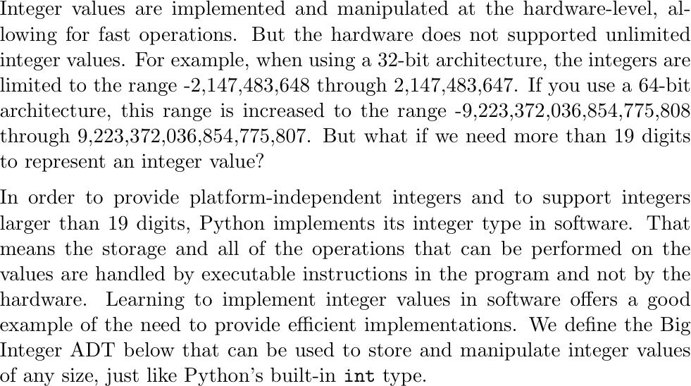

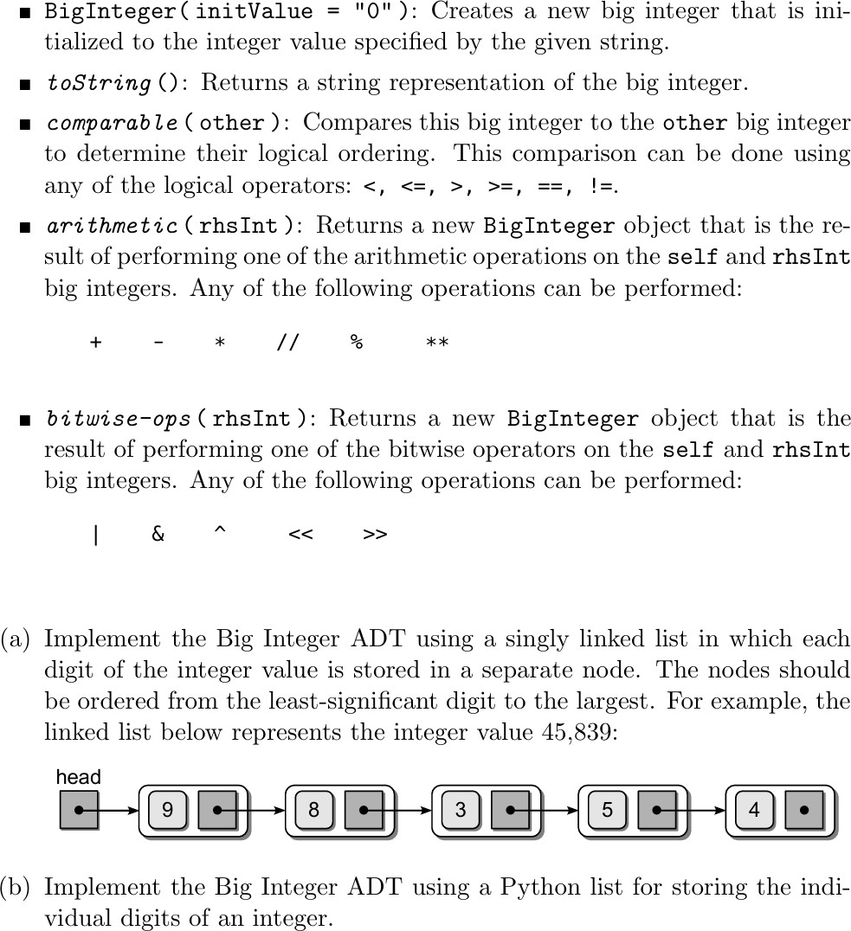
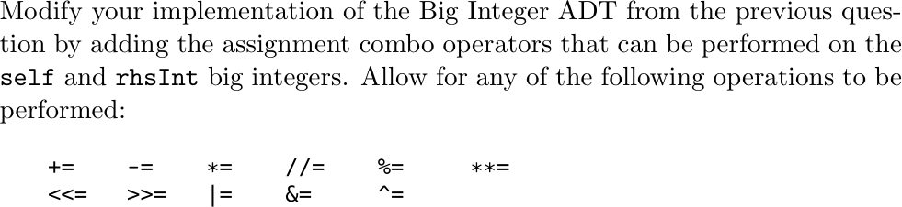
2.

ffff

